Freed forward neural network:
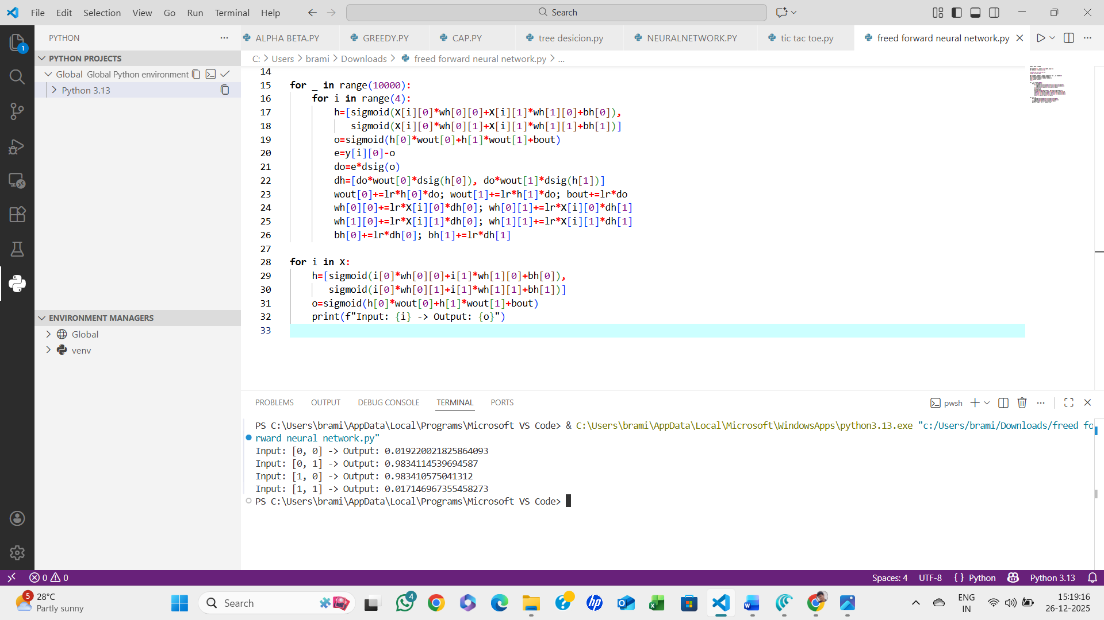

Algorithm:
- Initialize network parameters (weights and biases) randomly.
- Input layer receives input features.
- Forward propagation:
  - Compute weighted sum for each neuron in hidden layers.
  - Apply activation function (e.g., sigmoid, ReLU).
  - Repeat for all hidden layers and output layer.
- Compute output and compare with target (calculate error).
- Backpropagation (optional if training):
  - Compute gradients of error w.r.t weights.
  - Update weights and biases using learning rate.
- Repeat steps 3–5 for all training samples until convergence.
- Stop.

